Ray C. Ortlund, Jr. – The structure of Isaiah’s thought in chapter 11 is intricate, but his central focus is clear. At the close of chapter 10, what do we see? The infestation of human pride like a vast forest cut down. God swings his axe, and the whole evil system falls. Bare stumps as far as the eye can see. No branches waving in the wind, no birds flitting around, no life, no movement, no sound. The world is dead. But wait. Something new appears:

There shall come forth a shoot from the stump of Jesse,
and a branch from his roots shall bear fruit. (Isaiah 11:1)

From one stump a little shoot grows and becomes a branch and bears fruit. And the fruit it bears is a whole new world. Isaiah is thinking of a little boy, born in obscurity more than 2,000 years ago now, with no status but lineage in a failed ancient dynasty. And he is the only one who can save us from ourselves.

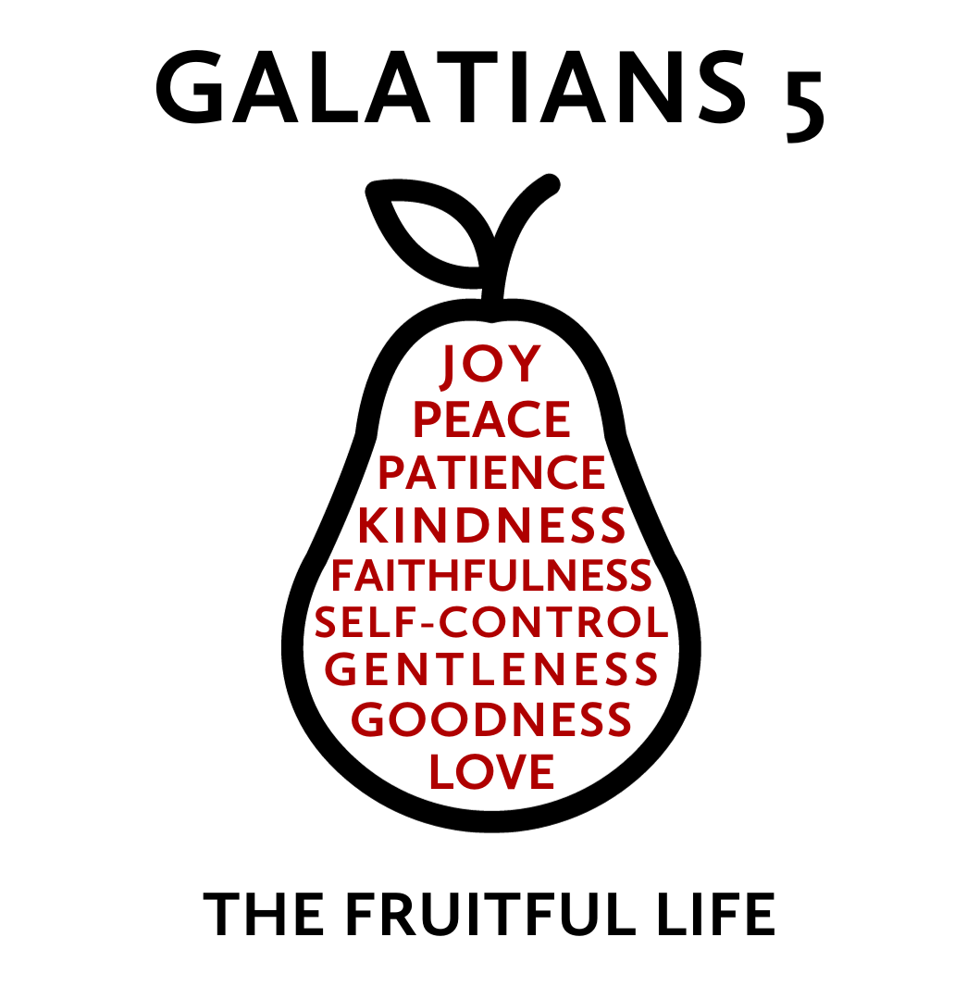But the fruit of the Spirit is love, joy, peace, patience, kindness, goodness, faithfulness, gentleness, self-control; against such things there is no law.
Galatians 5:22-23

What does real growth and change look like? The Bible describes an organic process in which the quality of Jesus’ own life is cultivated, by his Spirit, in the lives of his followers. This quality of life is not a list of virtues that we accomplish but “fruit” produced in us by the Holy Spirit as we actively delight in and rest in Jesus. While this fruit has many dimensions, each dimension grows in relationship to the others to increasingly form us as a whole person.
This “fruit” is the type of life we were originally designed to live but is now produced against the backdrop of a world marred by sin. As this fruit develops, it blesses those around us and creates a community that is a glimpse of the world to come—a community filled with individuals who are both unique in themselves and being conformed to the image of Jesus.
A Banner for the Peoples
December 24, 2023 | Isaiah 11 | Pastor Taylor Bradbury

Jesus Christ is the fruitful King who reigns over everything
and calls for all peoples to trust in him.

Isaiah 11
¹ There shall come forth a shoot from the stump of Jesse,
and a branch from his roots shall bear fruit.
² And the Spirit of the Lord shall rest upon him,
the Spirit of wisdom and understanding,
the Spirit of counsel and might,
the Spirit of knowledge and the fear of the Lord.
³ And his delight shall be in the fear of the Lord.
He shall not judge by what his eyes see,
or decide disputes by what his ears hear,
⁴ but with righteousness he shall judge the poor,
and decide with equity for the meek of the earth;
and he shall strike the earth with the rod of his mouth,
and with the breath of his lips he shall kill the wicked.
⁵ Righteousness shall be the belt of his waist,
and faithfulness the belt of his loins.

⁶ The wolf shall dwell with the lamb,
and the leopard shall lie down with the young goat,
and the calf and the lion and the fattened calf together;
and a little child shall lead them.
⁷ The cow and the bear shall graze;
their young shall lie down together;
and the lion shall eat straw like the ox.
⁸ The nursing child shall play over the hole of the cobra,
and the weaned child shall put his hand on the adder's den.
⁹ They shall not hurt or destroy
in all my holy mountain;
for the earth shall be full of the knowledge of the Lord
as the waters cover the sea.
¹⁰ In that day the root of Jesse, who shall stand as a signal for the peoples—of him shall the nations inquire, and his resting place shall be glorious.

1 The Triune God appointed a new king… (1–5)
Luke 4 ¹⁷ And the scroll of the prophet Isaiah was given to him. He unrolled the scroll and found the place where it was written,

¹⁸ “The Spirit of the Lord is upon me,
because he has anointed me
to proclaim good news to the poor.
He has sent me to proclaim liberty to the captives
and recovering of sight to the blind,
to set at liberty those who are oppressed,
¹⁹ to proclaim the year of the Lord's favor.”

²⁰ And he rolled up the scroll and gave it back to the attendant and sat down. And the eyes of all in the synagogue were fixed on him.²¹ And he began to say to them, “Today this Scripture has been fulfilled in your hearing.”

2 …who reigns over a new world… (6–9)

Romans 5:1 Therefore, since we have been justified by faith, we have peace with God through our Lord Jesus Christ.

2 Corinthians 5:17 Therefore, if anyone is in Christ, he is a new creation; old things have passed away; behold, all things have become new (NKJV).

Colossians 1 ¹³ He has delivered us from the domain of darkness and transferred us to the kingdom of his beloved Son, ¹⁴ in whom we have redemption, the forgiveness of sins.

3 …by forming a new people (10)

Psalm 110:1 The Lord says to my Lord:
“Sit at my right hand,
until I make your enemies your footstool.”

