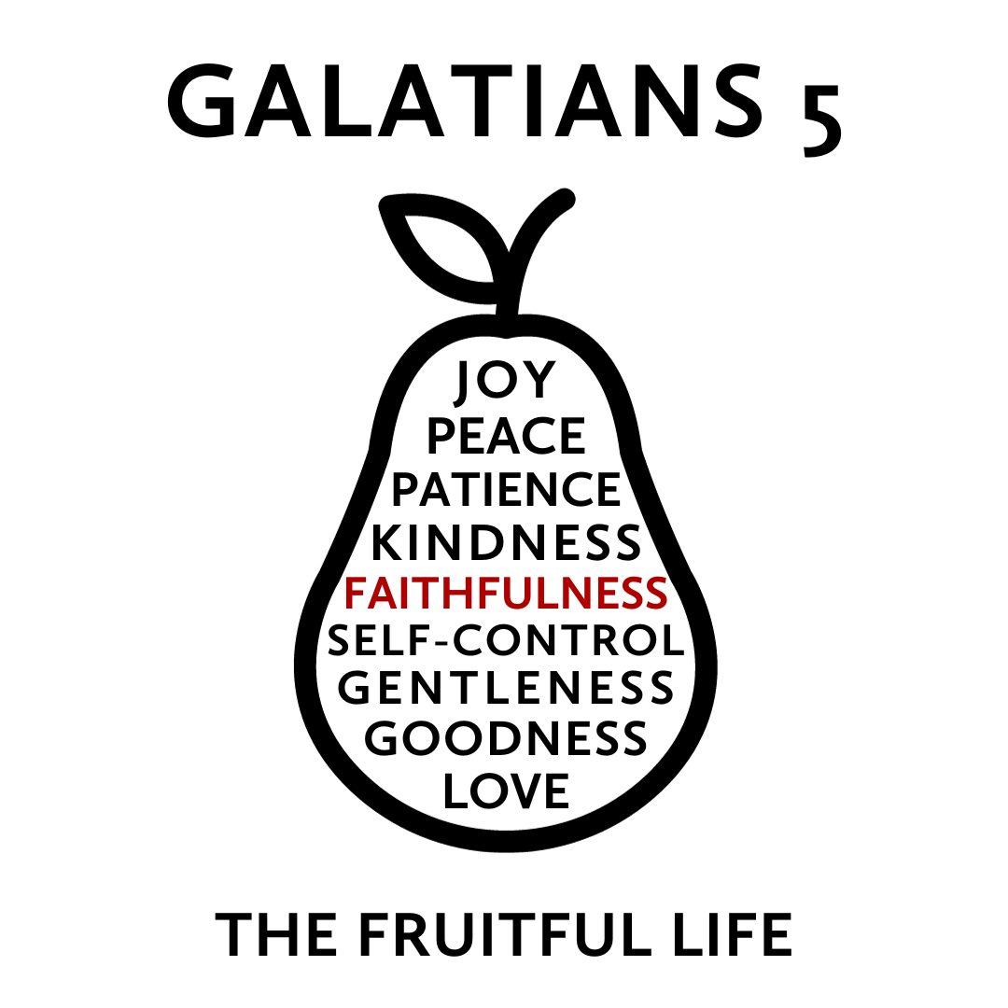

But the fruit of the Spirit is love, joy, peace, patience, kindness, goodness, faithfulness, gentleness, self-control; against such things there is no law.
Galatians 5:22-23
What does real growth and change look like? The Bible describes an organic process in which the quality of Jesus’ own life is cultivated, by his Spirit, in the lives of his followers. This quality of life is not a list of virtues that we accomplish but “fruit” produced in us by the Holy Spirit as we actively delight in and rest in Jesus. While this fruit has many dimensions, each dimension grows in relationship to the others to increasingly form us as a whole person.
This “fruit” is the type of life we were originally designed to live but is now produced against the backdrop of a world marred by sin. As this fruit develops, it blesses those around us and creates a community that is a glimpse of the world to come—a community filled with individuals who are both unique in themselves and being conformed to the image of Jesus.
Join us this Fall as we explore how this life of Jesus is cultivated in the life of his people and how this may lead you to a more Christlike version of yourself.
Faithfulness
December 3, 2023 | Galatians 5:22-23 | Pastor Taylor Bradbury

The Spirit produces faithfulness in us as we
behold the faithfulness of Christ.

Galatians 5
¹⁶ But I say, walk by the Spirit, and you will not gratify the desires of the flesh. ¹⁷ For the desires of the flesh are against the Spirit, and the desires of the Spirit are against the flesh, for these are opposed to each other, to keep you from doing the things you want to do.¹⁸ But if you are led by the Spirit, you are not under the law. ¹⁹ Now the works of the flesh are evident: sexual immorality, impurity, sensuality, ²⁰ idolatry, sorcery, enmity, strife, jealousy, fits of anger, rivalries, dissensions, divisions, ²¹ envy, drunkenness, orgies, and things like these. I warn you, as I warned you before, that those who do such things will not inherit the kingdom of God. ²² But the fruit of the Spirit is love, joy, peace, patience, kindness, goodness, faithfulness, ²³ gentleness, self-control; against such things there is no law.

-------------------------------------------------------------------------

Sinclair Ferguson “It’s always been very interesting to me that the words for faithfulness and faith in the Old Testament have the same root as the word amen. Faithfulness is just saying an ongoing amen to the commitments that we’ve made. God has given us a model of what this means. We don’t have to make it up because we see it perfectly expressed in the life and ministry of the Lord Jesus.”

2 Corinthians 1 ¹⁹ For the Son of God, Jesus Christ, whom we proclaimed among you, Silvanus and Timothy and I, was not Yes and No, but in him it is always Yes. ²⁰ For all the promises of God find their Yes in him. That is why it is through him that we utter our Amen to God for his glory. ²¹ And it is God who establishes us with you in Christ, and has anointed us, ²² and who has also put his seal on us and given us his Spirit in our hearts as a guarantee.

Hebrews 3 ¹ Therefore, holy brothers, you who share in a heavenly calling, consider Jesus, the apostle and high priest of our confession, ² who was faithful to him who appointed him, just as Moses also was faithful in all God's house.

1. What faithfulness is
reliability, fidelity, commitment, constancy
“That which evokes trust and faith; the state of being someone in whom confidence can be placed” (BDAG, Greek Lexicon).

Romans 4 ¹⁸ In hope he believed against hope, that he should become the father of many nations, as he had been told, “So shall your offspring be.” ¹⁹ He did not weaken in faith when he considered his own body, which was as good as dead (since he was about a hundred years old), or when he considered the barrenness of Sarah's womb. ²⁰ No unbelief made him waver concerning the promise of God, but he grew strong in his faith as he gave glory to God, ²¹ fully convinced that God was able to do what he had promised. ²² That is why his faith was “counted to him as righteousness.” ²³ But the words “it was counted to him” were not written for his sake alone, ²⁴ but for ours also. It will be counted to us who believe in him who raised from the dead Jesus our Lord, ²⁵ who was delivered up for our trespasses and raised for our justification.

2. The faithfulness of Jesus Christ
faithfulness seen in His person, His Cross, and His return

Romans 3:3–4 ³ What if some were unfaithful? Does their faithlessness nullify the faithfulness of God? ⁴ By no means! Let God be true though every one were a liar

Lamentations 3 ²² The steadfast love of the Lord never ceases;
his mercies never come to an end;
²³ they are new every morning;
great is your faithfulness.
²⁴ “The Lord is my portion,” says my soul,
“therefore I will hope in him.”

2 Thessalonians 3 ¹ Finally, brothers, pray for us, that the word of the Lord may speed ahead and be honored, as happened among you, ² and that we may be delivered from wicked and evil men. For not all have faith. ³ But the Lord is faithful. He will establish you and guard you against the evil one.

Revelation 19 ¹¹ Then I saw heaven opened, and behold, a white horse! The one sitting on it is called Faithful and True, and in righteousness he judges and makes war… ¹⁶ On his robe and on his thigh he has a name written, King of kings and Lord of lords.

3. Faithfulness worked in us
definition in relationships, in home, in church, in the world

