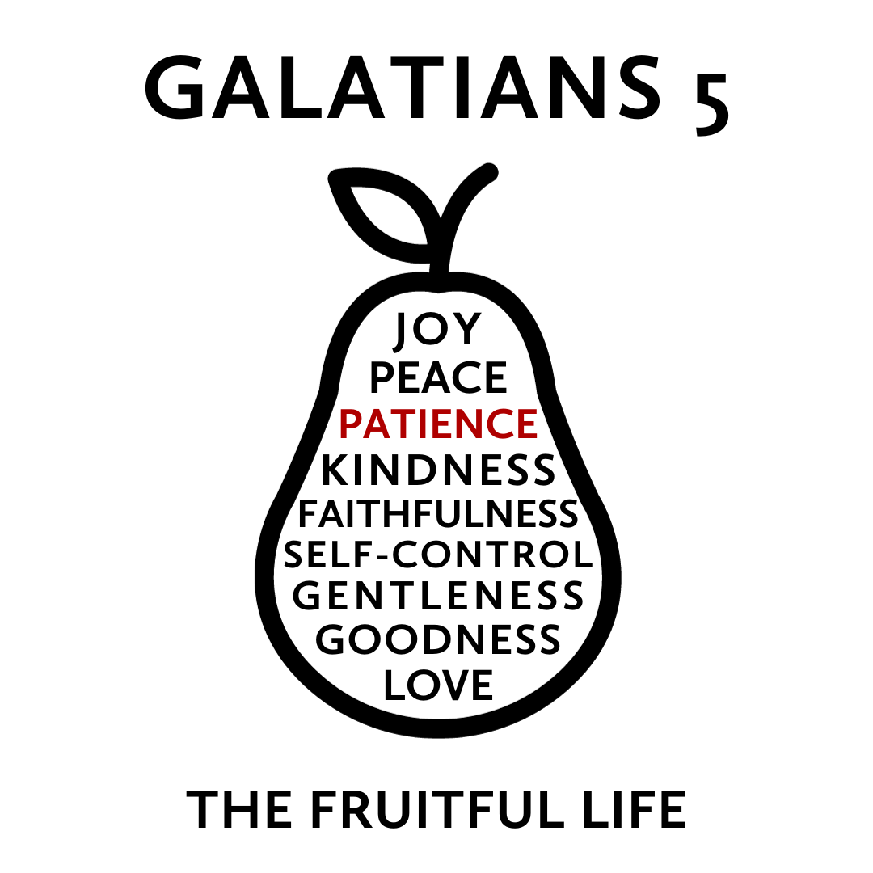
But the fruit of the Spirit is love, joy, peace, patience, kindness, goodness, faithfulness, gentleness, self-control; against such things there is no law.
Galatians 5:22-23
What does real growth and change look like? The Bible describes an organic process in which the quality of Jesus’ own life is cultivated, by his Spirit, in the lives of his followers. This quality of life is not a list of virtues that we accomplish but “fruit” produced in us by the Holy Spirit as we actively delight in and rest in Jesus. While this fruit has many dimensions, each dimension grows in relationship to the others to increasingly form us as a whole person.
This “fruit” is the type of life we were originally designed to live but is now produced against the backdrop of a world marred by sin. As this fruit develops, it blesses those around us and creates a community that is a glimpse of the world to come—a community filled with individuals who are both unique in themselves and being conformed to the image of Jesus.
Join us this Fall as we explore how this life of Jesus is cultivated in the life of his people and how this may lead you to a more Christlike version of yourself.
The Fight for Patience
November 12, 2023 | Galatians 5:22-23 | Pastor Taylor Bradbury
The Spirit of Jesus works patience in the people of Jesus
as we joyfully await the return of Jesus.

Galatians 5
¹⁶ But I say, walk by the Spirit, and you will not gratify the desires of the flesh. ¹⁷ For the desires of the flesh are against the Spirit, and the desires of the Spirit are against the flesh, for these are opposed to each other, to keep you from doing the things you want to do.¹⁸ But if you are led by the Spirit, you are not under the law. ¹⁹ Now the works of the flesh are evident: sexual immorality, impurity, sensuality, ²⁰ idolatry, sorcery, enmity, strife, jealousy, fits of anger, rivalries, dissensions, divisions, ²¹ envy, drunkenness, orgies, and things like these. I warn you, as I warned you before, that those who do such things will not inherit the kingdom of God. ²² But the fruit of the Spirit is love, joy, peace, patience, kindness, goodness, faithfulness, ²³ gentleness, self-control; against such things there is no law.

James 5
⁷ Be patient, therefore, brothers, until the coming of the Lord. See how the farmer waits for the precious fruit of the earth, being patient about it, until it receives the early and the late rains. ⁸ You also, be patient. Establish your hearts, for the coming of the Lord is at hand.⁹ Do not grumble against one another, brothers, so that you may not be judged; behold, the Judge is standing at the door. ¹⁰ As an example of suffering and patience, brothers, take the prophets who spoke in the name of the Lord. ¹¹ Behold, we consider those blessed who remained steadfast. You have heard of the steadfastness of Job, and you have seen the purpose of the Lord, how the Lord is compassionate and merciful.

- What is patience?

Patience is love for the long haul; it is bearing up under difficult circumstances, without giving up or giving in to bitterness. Patience means working when gratification is delayed. It means taking what life offers—even if it means suffering—without lashing out. And when you’re in a situation that you’re troubled over or when there’s a delay or pressure on you or something’s not happening that you want to happen, there’s always a temptation to come to the end of your patience. You may well have lost your patience before you’re even aware of it. ~Tim Keller, King’s Cross, 59

- Why do we struggle with patience?

Faith meets life’s tests and, through patience (and not without it), grows into full maturity of settled character (Jas 1:2–4). James’s doctrine of the Christian life is a doctrine of process or growth, and patience is its central requirement. ~ Alec Motyer, The Message of James, 169

3. How do we develop patience?

“The Lord is not slow to fulfill his promise as some count slowness, but is patient toward you, not wishing that any should perish, but that all should reach repentance.” (2 Peter 3:9)

“The LORD is merciful and gracious, slow to anger and abounding in steadfast love.” (Psalm 103:8)

