Want to learn more? Here are few suggested resources:

Blessed: Experiencing the Promise of the Book of Revelation, by Nancy Guthrie (2022).
This is a popular level book exploring the main themes of the book of Revelation and taking special care to explore how these themes encourage our life.

Revelation: A Shorter Commentary, by G.K. (Greg) Beale (2015).
This “shorter” commentary is still 500+ pages but he writes in a way that is accessible to serious Bible students. If you are looking for a verse-by-verse approach, this is what you want. It is a bit pricey but worth it! If you are super ambitious, you could get his longer commentary which clocks in at 1309 pages! Anything from Greg Beale is worthwhile.

The Triumph of the Lamb, by Dennis Johnson (2001).
This is less verse-by-verse and more section-by-section. It is scholarly, but very readable. Johnson is a scholar/pastor and writes with the churchgoer in mind.

Videos: scan QR code with your smartphone camera

Bible Project Video #1 | Bible Project Video #2

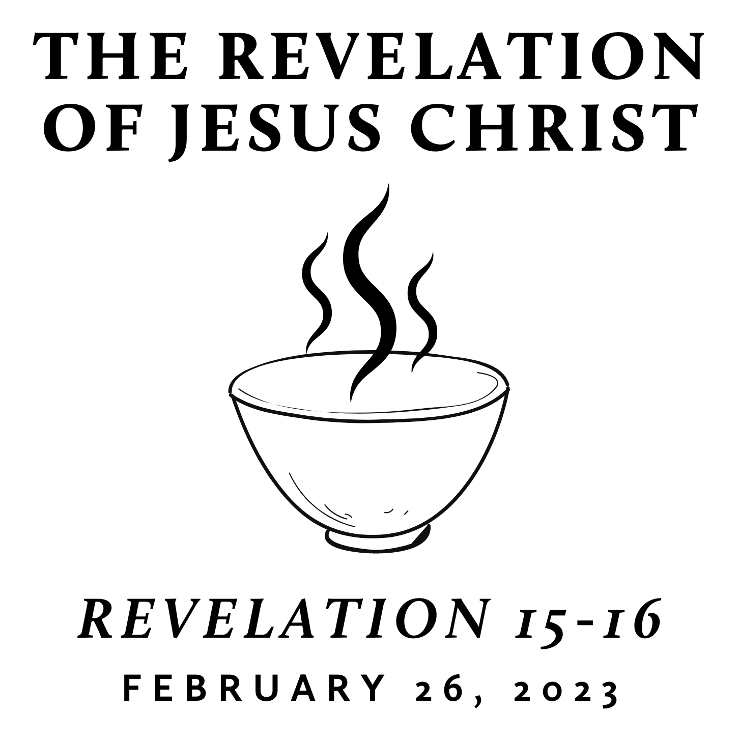

Fall/Winter 2022
Revelation is the last book of the Bible and is often treated as “mysterious” and “futuristic.” However, we contend that it only seems mysterious because it is full of images rooted in the Old Testament and first century Roman culture—from which we are far removed. A patient and careful reading yields an understanding that is neither bizarre nor exclusively future. Rather, we find the book of Revelation to be presently encouraging and empowering for the people of God. This is because it reveals heaven’s view of events that transpire on earth throughout history—including our history and the history of its original audience.

Pondering the Wrath of God
February 26, 2023 | Revelation 15–16 | Pastor Taylor Bradbury

Revelation 15
¹ Then I saw another sign in heaven, great and amazing, seven angels with seven plagues, which are the last, for with them the wrath of God is finished.
² And I saw what appeared to be a sea of glass mingled with fire—and also those who had conquered the beast and its image and the number of its name, standing beside the sea of glass with harps of God in their hands. ³ And they sing the song of Moses, the servant of God, and the song of the Lamb, saying,

“Great and amazing are your deeds,
O Lord God the Almighty!
Just and true are your ways,
O King of the nations!
⁴ Who will not fear, O Lord,
and glorify your name?
For you alone are holy.
All nations will come
and worship you,
for your righteous acts have been revealed.”

⁵ After this I looked, and the sanctuary of the tent of witness in heaven was opened, ⁶ and out of the sanctuary came the seven angels with the seven plagues, clothed in pure, bright linen, with golden sashes around their chests. ⁷ And one of the four living creatures gave to the seven angels seven golden bowls full of the wrath of God who lives forever and ever, ⁸ and the sanctuary was filled with smoke from the glory of God and from his power, and no one could enter the sanctuary until the seven plagues of the seven angels were finished.

Revelation 16
¹ Then I heard a loud voice from the temple telling the seven angels, “Go and pour out on the earth the seven bowls of the wrath of God.”
² So the first angel went and poured out his bowl on the earth, and harmful and painful sores came upon the people who bore the mark of the beast and worshiped its image.
³ The second angel poured out his bowl into the sea, and it became like the blood of a corpse, and every living thing died that was in the sea.
⁴ The third angel poured out his bowl into the rivers and the springs of water, and they became blood. ⁵ And I heard the angel in charge of the waters say,

“Just are you, O Holy One, who is and who was,
for you brought these judgments.
⁶ For they have shed the blood of saints and prophets,
and you have given them blood to drink.
It is what they deserve!”
⁷ And I heard the altar saying,
“Yes, Lord God the Almighty,
true and just are your judgments!”

⁸ The fourth angel poured out his bowl on the sun, and it was allowed to scorch people with fire. ⁹ They were scorched by the fierce heat, and they cursed the name of God who had power over these plagues. They did not repent and give him glory.
¹⁰ The fifth angel poured out his bowl on the throne of the beast, and its kingdom was plunged into darkness. People gnawed their tongues in anguish ¹¹ and cursed the God of heaven for their pain and sores. They did not repent of their deeds.
¹² The sixth angel poured out his bowl on the great river Euphrates, and its water was dried up, to prepare the way for the kings from the east. ¹³ And I saw, coming out of the mouth of the dragon and out of the mouth of the beast and out of the mouth of the false prophet, three unclean spirits like frogs. ¹⁴ For they are demonic spirits, performing signs, who go abroad to the kings of the whole world, to assemble them for battle on the great day of God the Almighty. ¹⁵ (“Behold, I am coming like a thief! Blessed is the one who stays awake, keeping his garments on, that he may not go about naked and be seen exposed!”) ¹⁶ And they assembled them at the place that in Hebrew is called Armageddon.

¹⁷ The seventh angel poured out his bowl into the air, and a loud voice came out of the temple, from the throne, saying, “It is done!” ¹⁸ And there were flashes of lightning, rumblings, peals of thunder, and a great earthquake such as there had never been since man was on the earth, so great was that earthquake. ¹⁹ The great city was split into three parts, and the cities of the nations fell, and God remembered Babylon the great, to make her drain the cup of the wine of the fury of his wrath. ²⁰ And every island fled away, and no mountains were to be found. ²¹ And great hailstones, about one hundred pounds each, fell from heaven on people; and they cursed God for the plague of the hail, because the plague was so severe.

