Want to learn more? Here are few suggested resources:

Blessed: Experiencing the Promise of the Book of Revelation, by Nancy Guthrie (2022).
This is a popular level book exploring the main themes of the book of Revelation and taking special care to explore how these themes encourage our life.

Revelation: A Shorter Commentary, by G.K. (Greg) Beale (2015).
This “shorter” commentary is still 500+ pages but he writes in a way that is accessible to serious Bible students. If you are looking for a verse-by-verse approach, this is what you want. It is a bit pricey but worth it! If you are super ambitious, you could get his longer commentary which clocks in at 1309 pages! Anything from Greg Beale is worthwhile.

The Triumph of the Lamb, by Dennis Johnson (2001).
This is less verse-by-verse and more section-by-section. It is scholarly, but very readable. Johnson is a scholar/pastor and writes with the churchgoer in mind.

Videos: scan QR code with your smartphone camera

Bible Project Video #1 | Bible Project Video #2

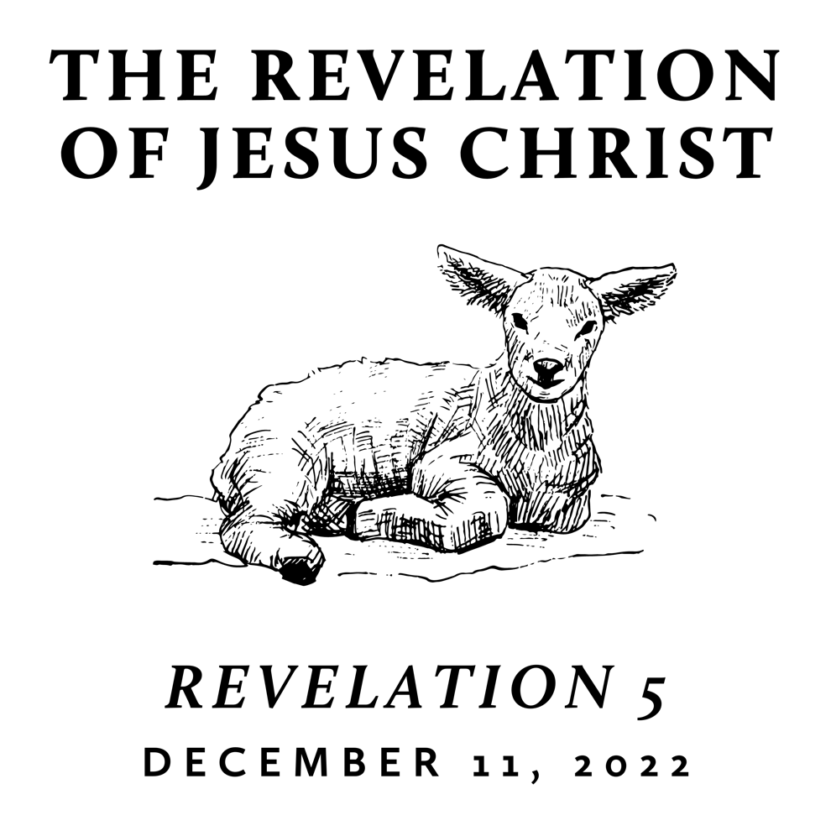

Fall/Winter 2022
Revelation is the last book of the Bible and is often treated as “mysterious” and “futuristic.” However, we contend that it only seems mysterious because it is full of images rooted in the Old Testament and first century Roman culture—from which we are far removed. A patient and careful reading yields an understanding that is neither bizarre nor exclusively future. Rather, we find the book of Revelation to be presently encouraging and empowering for the people of God. This is because it reveals heaven’s view of events that transpire on earth throughout history—including our history and the history of its original audience.

Worthy is the Lamb Who was Slain
December 11, 2022 | Revelation 5 | Pastor Taylor Bradbury

The Lamb of God is the point of history,

the hope of the world, and the song of the redeemed.

Revelation 5
¹ Then I saw in the right hand of him who was seated on the throne a scroll written within and on the back, sealed with seven seals. ² And I saw a mighty angel proclaiming with a loud voice, “Who is worthy to open the scroll and break its seals?” ³ And no one in heaven or on earth or under the earth was able to open the scroll or to look into it, ⁴ and I began to weep loudly because no one was found worthy to open the scroll or to look into it. ⁵ And one of the elders said to me, “Weep no more; behold, the Lion of the tribe of Judah, the Root of David, has conquered, so that he can open the scroll and its seven seals.”
⁶ And between the throne and the four living creatures and among the elders I saw a Lamb standing, as though it had been slain, with seven horns and with seven eyes, which are the seven spirits of God sent out into all the earth. ⁷ And he went and took the scroll from the right hand of him who was seated on the throne. ⁸ And when he had taken the scroll, the four living creatures and the twenty-four elders fell down before the Lamb, each holding a harp, and golden bowls full of incense, which are the prayers of the saints. ⁹ And they sang a new song, saying,
“Worthy are you to take the scroll
and to open its seals,
for you were slain, and by your blood you ransomed people for God
from every tribe and language and people and nation,
¹⁰ and you have made them a kingdom and priests to our God,
and they shall reign on the earth.”
¹¹ Then I looked, and I heard around the throne and the living creatures and the elders the voice of many angels, numbering myriads of myriads and thousands of thousands, ¹² saying with a loud voice,
“Worthy is the Lamb who was slain,
to receive power and wealth and wisdom and might
and honor and glory and blessing!”
¹³ And I heard every creature in heaven and on earth and under the earth and in the sea, and all that is in them, saying,
“To him who sits on the throne and to the Lamb
be blessing and honor and glory and might forever and ever!”
¹⁴ And the four living creatures said, “Amen!” and the elders fell down and worshiped.
---------------------------------------------

- The Slain Lamb is the Point of History (1–4)
Greg Beale: “The book is best understood as containing God’s plan of judgement and redemption, which has been set in motion by Christ’s death and resurrection but has yet to be completed.”

- The Slain Lamb is the Hope of the World (5–7)
1 Corinthians 1:18 For the word of the cross is folly to those who are perishing, but to us who are being saved it is the power of God.

- The Slain Lamb is the Song of the Redeemed (8–14)

