To the Church in Philadelphia
⁷ “And to the angel of the church in Philadelphia write: ‘The words of the holy one, the true one, who has the key of David, who opens and no one will shut, who shuts and no one opens.
⁸ “‘I know your works. Behold, I have set before you an open door, which no one is able to shut. I know that you have but little power, and yet you have kept my word and have not denied my name. ⁹ Behold, I will make those of the synagogue of Satan who say that they are Jews and are not, but lie—behold, I will make them come and bow down before your feet, and they will learn that I have loved you. ¹⁰ Because you have kept my word about patient endurance, I will keep you from the hour of trial that is coming on the whole world, to try those who dwell on the earth. ¹¹ I am coming soon. Hold fast what you have, so that no one may seize your crown. ¹² The one who conquers, I will make him a pillar in the temple of my God. Never shall he go out of it, and I will write on him the name of my God, and the name of the city of my God, the new Jerusalem, which comes down from my God out of heaven, and my own new name. ¹³ He who has an ear, let him hear what the Spirit says to the churches.’

To the Church in Laodicea
¹⁴ “And to the angel of the church in Laodicea write: ‘The words of the Amen, the faithful and true witness, the beginning of God's creation.
¹⁵ “‘I know your works: you are neither cold nor hot. Would that you were either cold or hot! ¹⁶ So, because you are lukewarm, and neither hot nor cold, I will spit you out of my mouth. ¹⁷ For you say, I am rich, I have prospered, and I need nothing, not realizing that you are wretched, pitiable, poor, blind, and naked. ¹⁸ I counsel you to buy from me gold refined by fire, so that you may be rich, and white garments so that you may clothe yourself and the shame of your nakedness may not be seen, and salve to anoint your eyes, so that you may see. ¹⁹ Those whom I love, I reprove and discipline, so be zealous and repent. ²⁰ Behold, I stand at the door and knock. If anyone hears my voice and opens the door, I will come in to him and eat with him, and he with me. ²¹ The one who conquers, I will grant him to sit with me on my throne, as I also conquered and sat down with my Father on his throne. ²² He who has an ear, let him hear what the Spirit says to the churches.’”

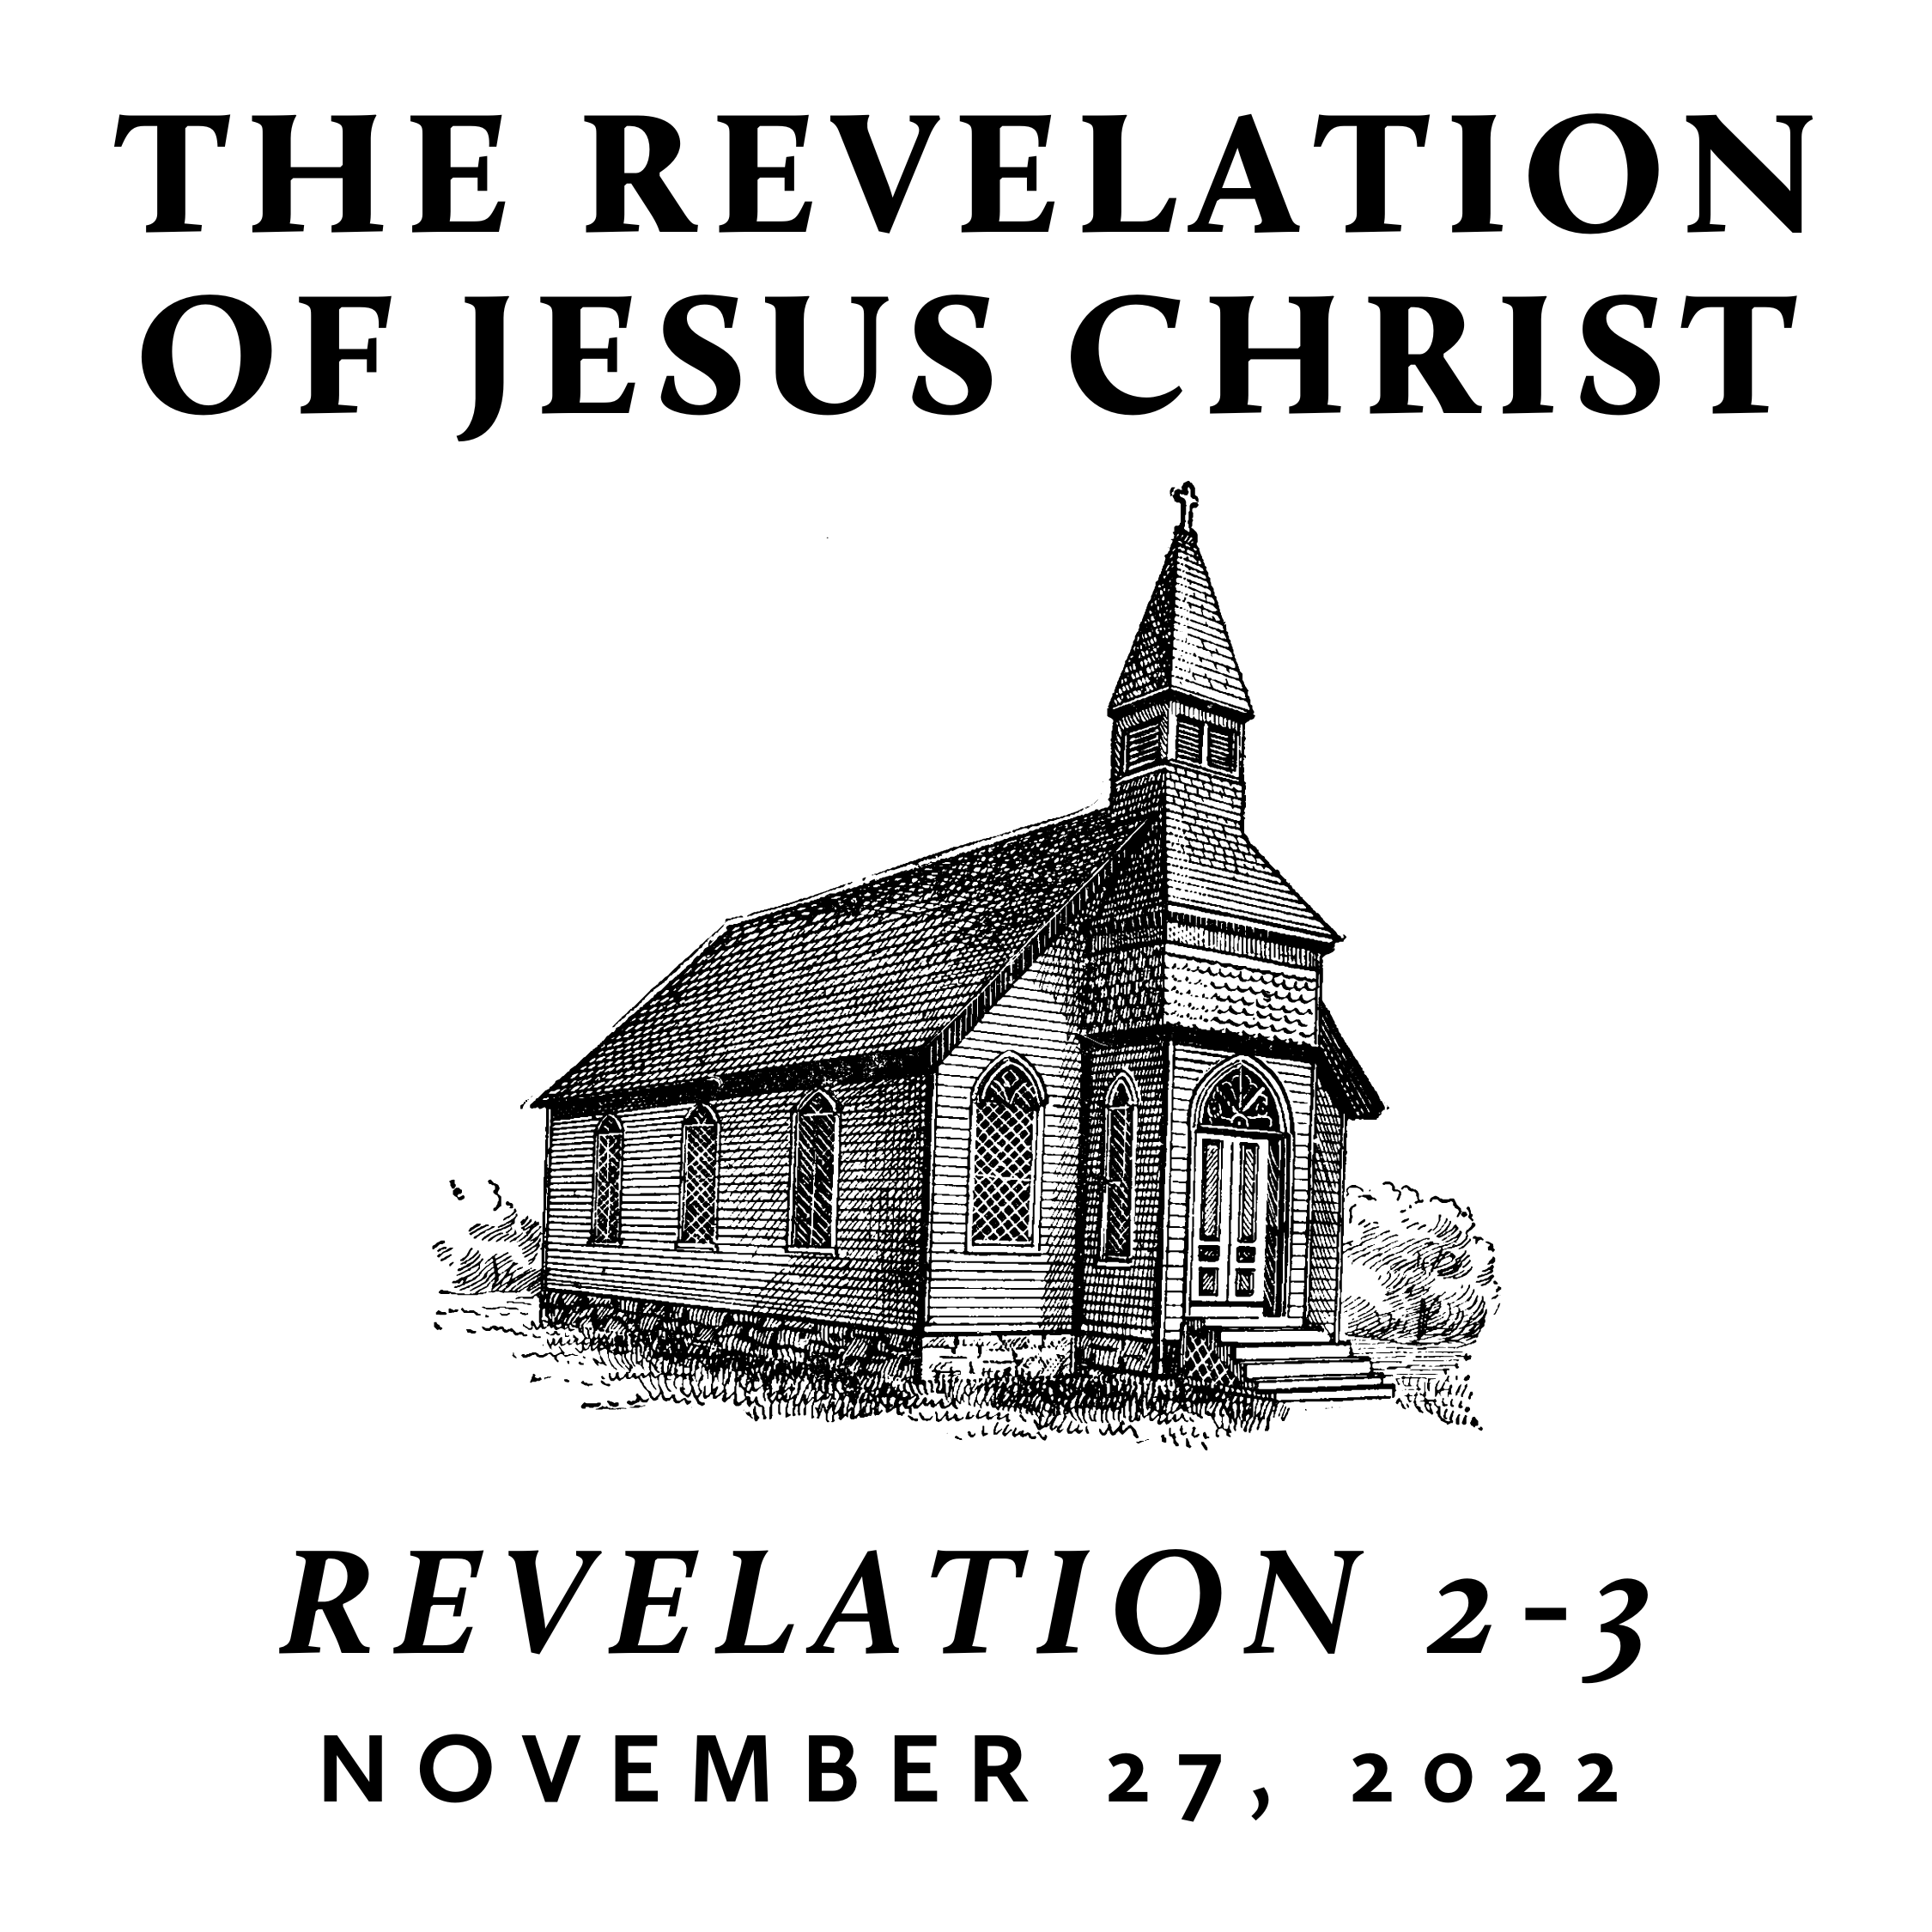

Fall/Winter 2022
Revelation is the last book of the Bible and is often treated as “mysterious” and “futuristic.” However, we contend that it only seems mysterious because it is full of images rooted in the Old Testament and first century Roman culture—from which we are far removed. A patient and careful reading yields an understanding that is neither bizarre nor exclusively future. Rather, we find the book of Revelation to be presently encouraging and empowering for the people of God. This is because it reveals heaven’s view of events that transpire on earth throughout history—including our history and the history of its original audience.

He who has an ear, let him hear…
November 27, 2022 | Revelation 2-3 | Pastor Taylor Bradbury

To the Church in Ephesus
Revelation 2 ¹“To the angel of the church in Ephesus write: ‘The words of him who holds the seven stars in his right hand, who walks among the seven golden lampstands.
² “‘I know your works, your toil and your patient endurance, and how you cannot bear with those who are evil, but have tested those who call themselves apostles and are not, and found them to be false. ³ I know you are enduring patiently and bearing up for my name's sake, and you have not grown weary. ⁴ But I have this against you, that you have abandoned the love you had at first. ⁵ Remember therefore from where you have fallen; repent, and do the works you did at first. If not, I will come to you and remove your lampstand from its place, unless you repent. ⁶ Yet this you have: you hate the works of the Nicolaitans, which I also hate. ⁷ He who has an ear, let him hear what the Spirit says to the churches. To the one who conquers I will grant to eat of the tree of life, which is in the paradise of God.’

To the Church in Smyrna
⁸ “And to the angel of the church in Smyrna write: ‘The words of the first and the last, who died and came to life.
⁹ “‘I know your tribulation and your poverty (but you are rich) and the slander of those who say that they are Jews and are not, but are a synagogue of Satan. ¹⁰ Do not fear what you are about to suffer. Behold, the devil is about to throw some of you into prison, that you may be tested, and for ten days you will have tribulation. Be faithful unto death, and I will give you the crown of life. ¹¹ He who has an ear, let him hear what the Spirit says to the churches. The one who conquers will not be hurt by the second death.’

To the Church in Pergamum
¹² “And to the angel of the church in Pergamum write: ‘The words of him who has the sharp two-edged sword.
¹³ “‘I know where you dwell, where Satan's throne is. Yet you hold fast my name, and you did not deny my faith even in the days of Antipas my faithful witness, who was killed among you, where Satan dwells. ¹⁴ But I have a few things against you: you have some there who hold the teaching of Balaam, who taught Balak to put a stumbling block before the sons of Israel, so that they might eat food sacrificed to idols and practice sexual immorality. ¹⁵ So also you have some who hold the teaching of the Nicolaitans. ¹⁶ Therefore repent. If not, I will come to you soon and war against them with the sword of my mouth. ¹⁷ He who has an ear, let him hear what the Spirit says to the churches. To the one who conquers I will give some of the hidden manna, and I will give him a white stone, with a new name written on the stone that no one knows except the one who receives it.’

To the Church in Thyatira
¹⁸ “And to the angel of the church in Thyatira write: ‘The words of the Son of God, who has eyes like a flame of fire, and whose feet are like burnished bronze.
¹⁹ “‘I know your works, your love and faith and service and patient endurance, and that your latter works exceed the first. ²⁰ But I have this against you, that you tolerate that woman Jezebel, who calls herself a prophetess and is teaching and seducing my servants to practice sexual immorality and to eat food sacrificed to idols. ²¹ I gave her time to repent, but she refuses to repent of her sexual immorality. ²² Behold, I will throw her onto a sickbed, and those who commit adultery with her I will throw into great tribulation, unless they repent of her works, ²³ and I will strike her children dead. And all the churches will know that I am he who searches mind and heart, and I will give to each of you according to your works. ²⁴ But to the rest of you in Thyatira, who do not hold this teaching, who have not learned what some call the deep things of Satan, to you I say, I do not lay on you any other burden. ²⁵ Only hold fast what you have until I come. ²⁶ The one who conquers and who keeps my works until the end, to him I will give authority over the nations, ²⁷ and he will rule them with a rod of iron, as when earthen pots are broken in pieces, even as I myself have received authority from my Father. ²⁸ And I will give him the morning star. ²⁹ He who has an ear, let him hear what the Spirit says to the churches.’

To the Church in Sardis
Revelation 3 ¹ “And to the angel of the church in Sardis write: ‘The words of him who has the seven spirits of God and the seven stars.
“‘I know your works. You have the reputation of being alive, but you are dead. ² Wake up, and strengthen what remains and is about to die, for I have not found your works complete in the sight of my God. ³ Remember, then, what you received and heard. Keep it, and repent. If you will not wake up, I will come like a thief, and you will not know at what hour I will come against you. ⁴ Yet you have still a few names in Sardis, people who have not soiled their garments, and they will walk with me in white, for they are worthy. ⁵ The one who conquers will be clothed thus in white garments, and I will never blot his name out of the book of life. I will confess his name before my Father and before his angels. ⁶ He who has an ear, let him hear what the Spirit says to the churches.’

