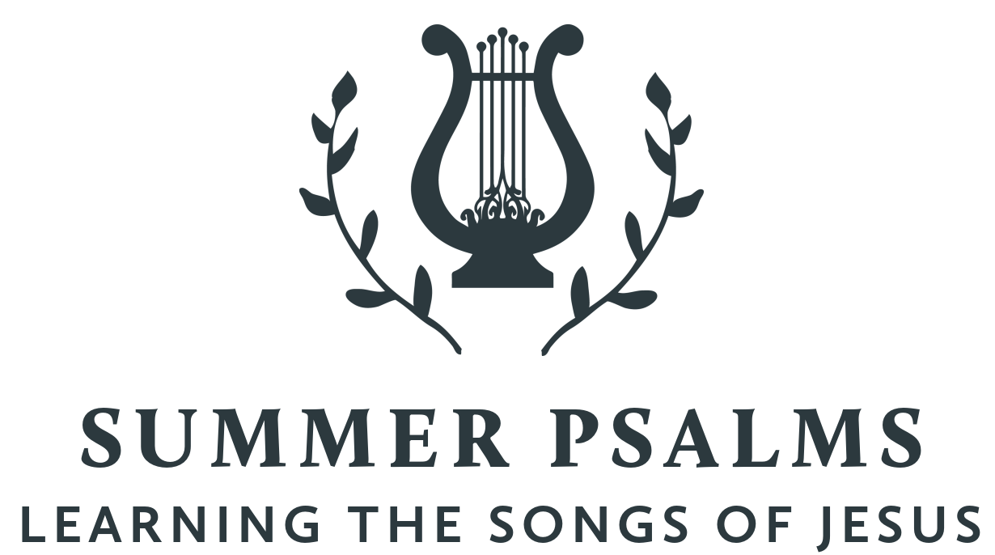

New City is spending time this summer exploring the Psalms – the songbook given by God to his people for worship, community, and a hopeful realism. This was modeled well in the life of Jesus. Though separated by language, culture, and generations, the Psalms are still the inspired and reliable guide to our own hearts and a constant help in honestly navigating the chaos of our world with God-honoring, Christ-centered, hope-filled resiliency

The City of God
July 17, 2022 | Psalm 48 | Pastor Taylor Bradbury

God dwelling among his rescued and reconciled people is the goal of creation and redemption.

Psalm 48

A Song. A Psalm of the Sons of Korah.
¹ Great is the Lord and greatly to be praised
in the city of our God!
His holy mountain, ² beautiful in elevation,
is the joy of all the earth,
Mount Zion, in the far north,
the city of the great King.
³ Within her citadels God
has made himself known as a fortress.

⁴ For behold, the kings assembled;
they came on together.
⁵ As soon as they saw it, they were astounded;
they were in panic; they took to flight.
⁶ Trembling took hold of them there,
anguish as of a woman in labor.
⁷ By the east wind you shattered
the ships of Tarshish.
⁸ As we have heard, so have we seen
in the city of the Lord of hosts,
in the city of our God,
which God will establish forever. Selah

⁹ We have thought on your steadfast love, O God,
in the midst of your temple.
¹⁰ As your name, O God,
so your praise reaches to the ends of the earth.
Your right hand is filled with righteousness.
¹¹ Let Mount Zion be glad!
Let the daughters of Judah rejoice
because of your judgments!

¹² Walk about Zion, go around her,
number her towers,
¹³ consider well her ramparts,
go through her citadels,
that you may tell the next generation
¹⁴ that this is God,
our God forever and ever.
He will guide us forever.

- God (1, 14)

- God’s City (2–8)

- God’s Temple in God’s City (9–13)

